**Hot Meals History**

Hot Meals for the Hungry at St. Mark’s Episcopal Church began in 1988, when parishioner Tom Stoever, then a graduate student at the University of California, realized the need for a meal service on weekends to supplement the daily services provided by the Berkeley Emergency Food Project. St Mark's was one of a few of the churches near the university campus (known as the "Sather Gate" churches) that responded to this call, many of which continue to provide meals to this day.

Tom was joined by Paul Brumbaum, together with other St. Mark’s parishioners to get the new meal program up and running. Cooking hot meals for a large group of people is a very different from cooking meals at home, and the new Hot Meals program was fortunate to have volunteers who were professional chefs such as Annie May de Bresson and Phil Brown. They helped outfit the kitchen and taught the rest of the volunteers how to boil pasta for 100 guests without burning it! Over time, it became a Hot Meals tradition to cook a meal that was not just hot, but really genuinely fresh and delicious, cooked with wholesome ingredients, one that we would want to eat ourselves.

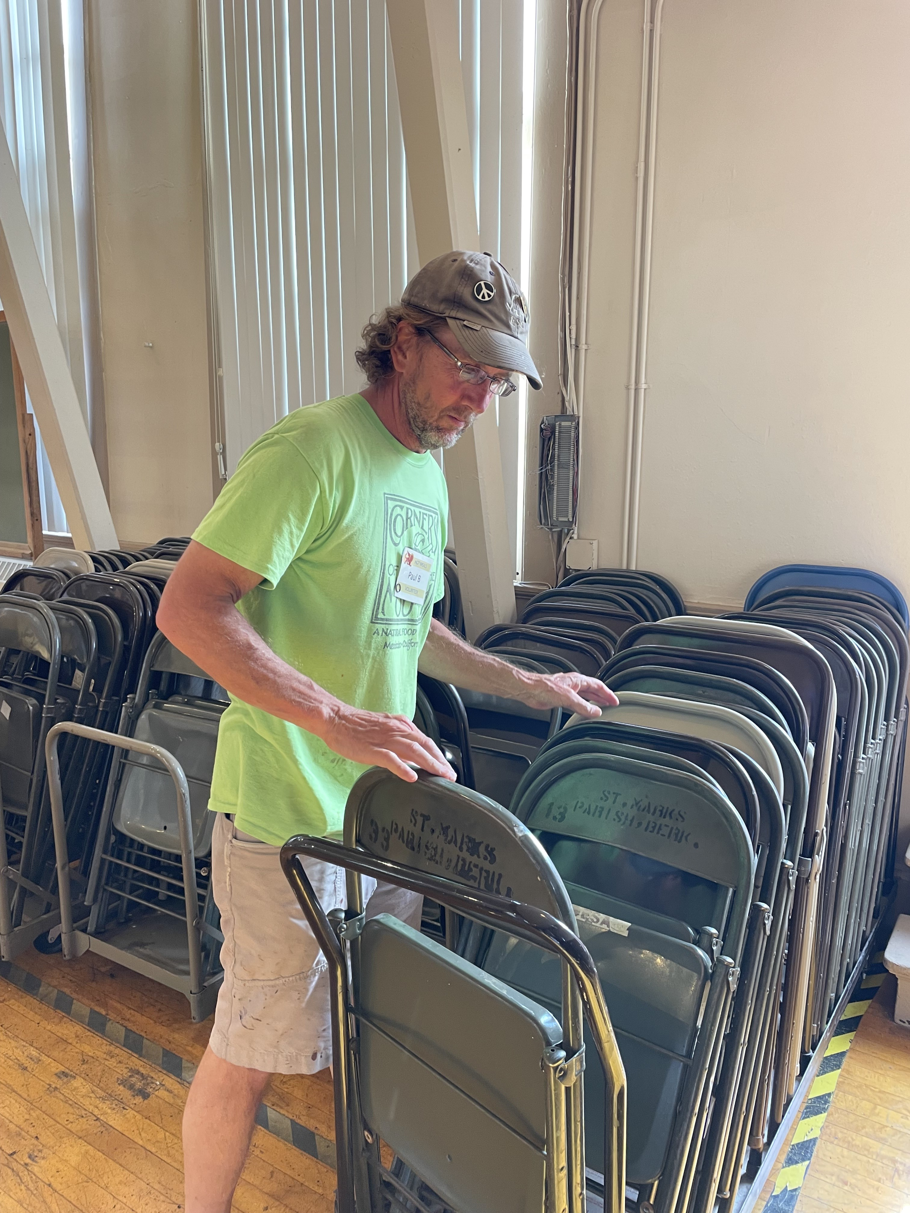

*Hot Meals co-founder Paul Brumbaum continues to serve Hot Meals to this day.*

In St. Matthew’s gospel (chapter 25), Jesus says said, “Truly I tell you, just as you did it to one of the least of these brothers and sisters of mine, you did it to me.” This truth was a cornerstone for Hot Meals at its founding and is part of its ethos that continues to this day.

Hot Meals would not have continued for more than 35 years were it not for the efforts of countless volunteers, both from within and outside the St. Mark's community. Some of the parishioners who have been leaders over the years have included Sandy Brumbaum, Anna Weidman, Jennie Curtis, Charlotte Blackner, and Ian Tse and Kat McEachern. Many others from outside St. Mark's have joined in the mission, especially youth doing community service, and many varied groups from the Berkeley and/or university community.

Surely one reason so many have returned to keep Hot Meals running for so long is that the needs of the hungry and unhoused in our community sadly continues. Perhaps another, is that in feeding others we discover that it is we ourselves who are being fed.

